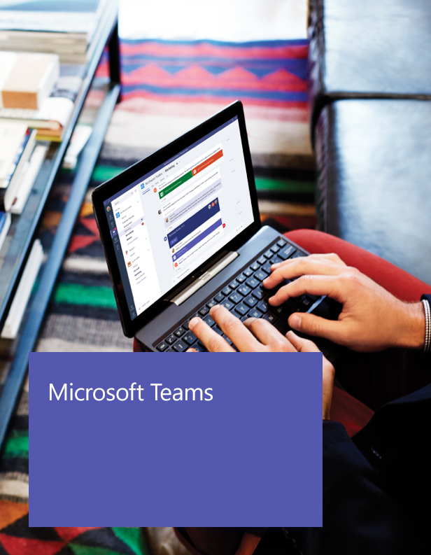

Leaders

Getting started with Microsoft Teams

Microsoft Teams is the chat-centered workspace that is integrated with Office 365. It gives teams instant access to everything they need in a dedicated hub for teamwork where chat, content, people, and tools live together in Office 365.

Welcome, we’re glad you’re here!

This guide is designed to help you make the most of Microsoft Teams. As a team owner, you play a critical role in defining the purpose of your team and getting everyone on board to work together in one place.

It’s easy to get started!

Start using Microsoft Teams with your team by following the steps outlined in this guide. It includes all the resources you need to be successful.

1. Understand Microsoft Teams
2. Create a team
3. Invite members
4. Engage members
5. Understand Microsoft Teams

Core Values

Microsoft Teams is designed for highly engaged teams that work closely together to get things done:

* Share updates and give feedback in the open
* Make quick decisions and stay in the loop with team activities
* Coordinate on projects and tasks, including co-create content and deliverables

Before you create your team, there’s a few things you should know about the deployment and structure of Microsoft Teams, including team membership, roles, and settings.

Deployment

As an Office 365 customer, your IT admin may need to activate Microsoft Teams across your organization in the Admin Center. Once it is activated, you can access it through the Microsoft app launcher on the [Microsoft online login page](https://login.microsoftonline.com/). Click on the Microsoft Teams tile to open the online app and download Microsoft Teams to your desktop.

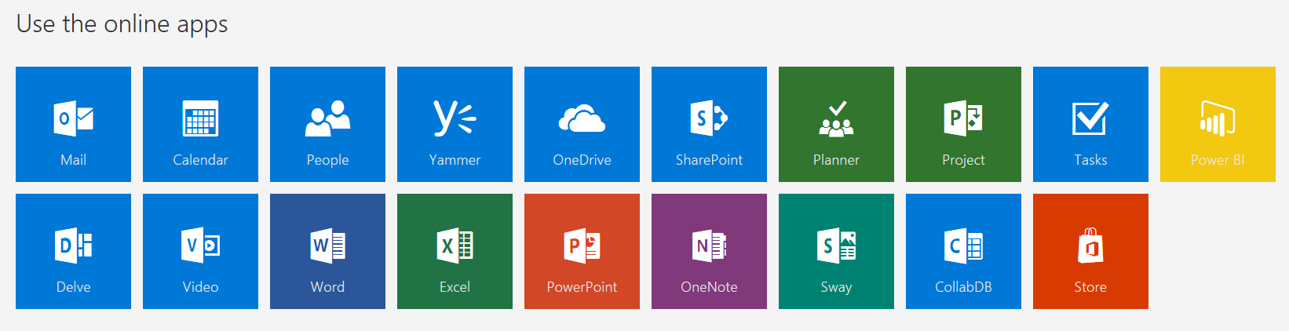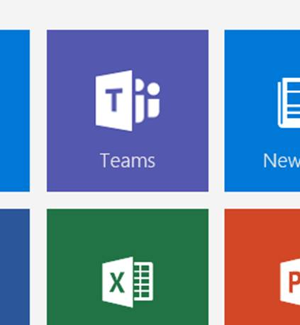

Structure

Organization

All teams created by employees in your organization are associated with your Office 365 tenant. You can designate all employees or a subset of employees with the ability to create teams, using Office 365 Groups.

Team

A team is designed to bring together a group of people that work closely to get things done. Teams can be dynamic for project-based work (E.g. launching a product, creating a digital war room), as well as ongoing, to reflect the internal structure of your organization (E.g. departments and office locations). Conversations, files, and notes across team channels are only visible to members of the team.

Channel

A channel helps organize the team’s conversations, content, and tools around a specific topic. Channels can be organized, for example, by topic (events), discipline (design), project (launch), or just for fun (fun stuff). Team owners can create channels, and enable team members with the ability to create channels, as needed. Tabs along the top of a channel enable teams to keep files, notes, and customized content such as Power BI metrics, business goals on a Word doc, or organizational chart on a PowerPoint slide. This content is then easily accessible to everyone on the team. Additional connectors to 3rd party applications can be customized at the channel level to bring in data from everyday tools such as Trello, Asana, GitHub, and more.

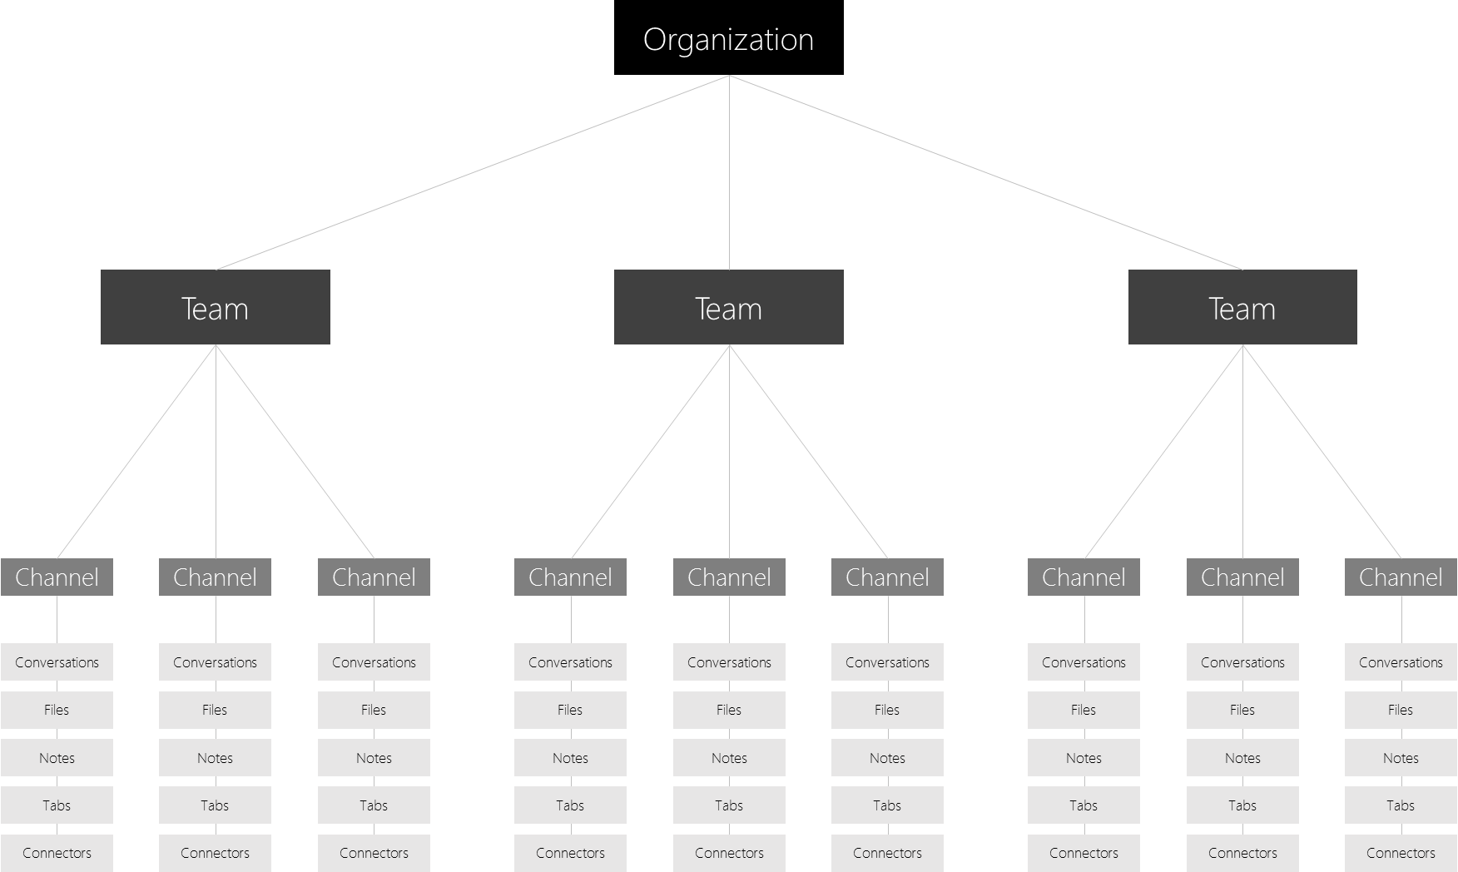

Team Membership

When Microsoft Teams is activated for your entire organization, designated team owners are able to invite any employee* they work with to join their team. Microsoft Teams makes it easy for team owners to add people in the organization based on their name.

Team owners can also create a team based on an existing Office 365 Group. Any changes made to the group will be synched with Microsoft Teams automatically. Creating a team based on an existing Office 365 Group not only simplifies the process of inviting and managing members, but also syncs group files inside of Microsoft Teams.

*Microsoft Teams does not currently support the ability for users outside of your organization to join teams.

Team Roles

There are two main roles in Microsoft Teams: a team owner, the person who creates the team, and team members, the people who they invite to join their team. Team owners can make any member of their team a co-owner when they invite them to the team or at any point after they’ve joined the team. Having multiple team owners enables you to share the responsibilities of managing settings and membership, including invitations.

Team Settings

Team owners can manage team-wide settings directly in Microsoft Teams. Settings include the ability to add a team picture, set permissions across team members for creating channels, adding tabs and connectors, @mentioning the entire team or channel, and the usage of GIFs, stickers, and memes.

As a Microsoft Teams admin, you have access to system-wide settings in the admin center. These settings can impact the options and defaults team owners see under team settings. For example, you can enable a default channel, “General”, for team-wide announcements, discussions, and resources, which will appear across all teams.

1. Create a team

Define the team’s purpose

Spend some time thinking about the purpose of the team you are creating. When you create the team, add this in the description field for team members to see.

**Tip:** Starting with a project-based team is a great way to experience Microsoft Teams without disrupting existing workflows.

Stage the team environment

In addition to the default “General” channel, you can create some additional channels for team members to see (E.g. “Fun” for water cooler conversations and for team deliverables). Seed channels with messages and resources to make team members feel welcome.

**Tip:** Keeping the staging to a minimum allows users to organically create channels, customize tabs, and add connectors as needed. You can always take away the ability for team members to do any of these things.

1. Invite members

Host a team meeting

The best way to get your team excited about Microsoft Teams is to get everyone together, whether in person, or virtually. Schedule a team meeting to introduce Microsoft Teams. As your IT Admin for some templates and materials to help you host your meeting.

Why Microsoft Teams

Kick off the meeting by explaining your goals for using Microsoft Teams, and how you envision working together with this service.

Introduction and demo

Introduce Microsoft Teams by showing the [Microsoft Teams video](https://go.microsoft.com/fwlink/p/?linkid=827928), then jump into a live demo of the team you created.

**Tip:** Highlighting your favorite features makes the demo more personal and fun.

Scope of use

Ask team members to commit using Microsoft Teams as the primary way to communicate with each other and collaborate on projects. Team members will continue to use other communication tools, like email, to work with people outside of this close knit team.

**Tip:** Commit to at least one week to ensure team members start to experience the benefits of using Microsoft Teams.

Norms

Encourage team members to communicate in the team channels, rather than one-on-one chats and groups. This creates a team culture of transparency which deepens the connection between team members and also helps to move the project forward when everyone has access to decisions and shared materials.

Conventions

Brainstorm the right set of initial channels to create and suggest a light-weight process for creating and naming channels across your team to keep things focused and organized.

Setup

Take advantage of this time together to get them signed into Microsoft Teams using the [web client](http://teams.microsoft.com/), where they can download desktop apps for Windows and Mac. Advise team members to download mobile apps in the App Store, Google Play, and Microsoft Store.

**Tip:** Getting Microsoft Teams set up on team members’ mobile devices will ensure they don’t miss a thing.

Follow up with the team

After your team meeting, follow up with an email summarizing your discussion, and providing next steps and resources for team members. Check with your IT Admin for these resources.

Provide training and help

Encourage team members to ask for help in a “Feedback” channel you can create in Microsoft Teams. Host chat-based trainings and Q&A sessions directly in Microsoft Teams.

**Tip:** Use the T-bot, a built-in help tool found by clicking on Chats, is another great way for team members to get help.

1. Engage members

Shift work to Microsoft Teams

Maintain momentum by shifting important discussions, updates and content into Microsoft Teams. This will make team members feel confident about making the switch. In the meantime, they will receive timely email notifications for any unread chats or @mentions, and other activities.

Use connectors and tabs

Bring live updates and data from 3rd party applications and services such as Trello, GitHub, and Asana, directly into Microsoft Teams. This will save your team time from checking multiple tools to get timely information.

Submit feedback and ideas

Bring your team’s feedback and ideas to your IT admin. Work together to build custom integrations for key 3rd party applications and bots tailored made for your team.

Set up IT organization on Microsoft Teams

Introduction

Before you roll out Microsoft Teams to your entire organization, it is recommended that you begin with 2-3 pilot teams. This will help you refine your launch plan and ensure you are ready for an organization-wide deployment.

Steps

1. Identify the projects you will be working on in Microsoft Teams
2. Create a Microsoft Team for each of the projects
3. Identify the work streams for each project and create channels within each Microsoft Team
4. Identify people that should be added as members to each of the teams
5. Pre-populate channels with important information
6. Kick off your new Microsoft Team with new team members
7. Check in with team members

An IT Admin is typically involved in driving several projects simultaneously. These projects might include things like network upgrades, router upgrades, system upgrades, and migrations. In addition, there may be communication with different groups in the company, such as support staff, legal, HR, or executives. Here, we will illustrate how Microsoft Teams can help IT Admins organize and manage projects quickly and efficiently. For the purposes of this guide, we use the deployment of a system upgrade as our sample scenario.

Step 1: Identify the projects you will be working on

In this guide, the project is the deployment of a system upgrade.

Step 2: Create a Microsoft Team for the desktop upgrade project

In our example, you will create a Microsoft Team for the scheduled upgrade of the operating system on users’ desktops.

**Microsoft Team name**: Desktop OS Upgrade

### **Step 3:** Identify the work streams and create channels for the Desktop OS Upgrade Team

After identifying the work streams that are necessary for this project, you create channels. A channel helps organize the team’s conversations, content, and tools around a specific topic. Channels can be organized, for example, by topic (events), discipline (design), project (launch), or just for fun (fun stuff). Team owners can create channels, and enable team members with the ability to create channels, as needed.

Suggested channels in the Desktop OS Upgrade Team are:

Channel names:

* Planning
* Deployment
* Operations
* Pre-deployment Issues
* Post-deployment Issues
* Application management and deployment
* Developer tools
* Test
* Feedback

### **Step 4:** Identify people that should be invited as members of the Desktop OS Upgrade Team

In this step, you identify the people needed to support this project. Often times, projects are cross-functional as input is needed from other functions to ensure a successful project. For the Desktop OS Upgrade Team, you might invite the following people or roles to the Desktop OS Upgrade Team to participate in the upgrade project.

Team members:

* Chief Technology Officer
* Information Technology Officer
* IT Change Management
* Network Administrators
* Project Management
* Pilot End Users

### **Step 5:** Pre-populate channels with important information

It’s recommended that you populate your channels with one or two questions related to that channel so that members aren’t greeted with empty space. For the Test channel, for example, a question to ask might be, “can someone share the test plan for the OS deployment?”

Tabs along the top of a channel enable teams to easily access files and notes for that channel. You have the option of creating a custom tab for information that you want to make easily accessible to the team, such as Power BI metrics, project goals, or an organizational chart. Deployment sheets are commonly used during desktop upgrades. To provide easy access to the deployment sheet document in Word, you might add it as

a tab in the Deployment channel. Add a Tab by clicking the “+” sign at the top of Microsoft Teams, next to Conversations, Files, and Notes.

Connectors allow Microsoft Teams users to receive updates from popular online services. When you connect a tool or service to a channel, everyone in the team can see the messages delivered by that service. In this example of a IT rolling out a desktop upgrade, you might want to add a connector for Trello or Asana for project management, and Zendesk for help desk issues that occur after the deployment. View available Connectors by clicking on the “ **. . .** “ at the top of Microsoft Teams next to the Team and Channel names.

### **Step 6:** Kick off your new Microsoft Team with new team members

The best way to get your team members excited about using Microsoft Teams is to get everyone together, whether in person or virtually. Schedule a team meeting to introduce Microsoft Teams, discuss the many features and benefits, and get team members to experience Microsoft Teams. Kick off the meeting by explaining your goals for using Microsoft Teams, and how you envision working together. You might introduce Microsoft Teams by showing a [product video](https://go.microsoft.com/fwlink/p/?linkid=827928), a [product tour](https://youtu.be/bhIzp2tFXYQ), or jumping into a live demo of the team you created.

Areas that you may want to discuss in the meeting include:

* Encourage team members to communicate using the Conversations tab in the channels, rather than one-on-one chats and groups. This creates a team culture of transparency which deepens the connection between team members and the connection of team members with the project.
* Encourage members to create channels for topics that arise and suggest a light-weight process for creating and naming channels across your team to keep things focused and organized.
* Describe how chat can be used for private 1:1 conversations or small group conversations. Audio or video calls can be added to any chat or team conversation.
* Explain how team members can share files, such as common deliverables, for feedback. Edits and comments by team members are saved right back to the document.
* Describe how you can capture team notes in the Notes tab to document ad hoc notes or meeting minutes.
* Explain the benefits of tabs, bots, and connectors and show how they can be added.
* Take advantage of this time together to get them signed into [Microsoft Teams](https://teams.microsoft.com) and download the mobile apps from the App Store, Google Play store, or Microsoft Store.

### **Step 7:** Check in with Team members

After your meeting, follow up with an email summarizing your discussion and providing next steps and resources for team members. Host chat-based trainings and Q&A sessions directly in Microsoft Teams.

Maintain momentum by shifting important discussions, updates, and content into Microsoft Teams. This will make Team members feel confident about making the switch. In the meantime, they will receive timely email notifications for any unread chats or @mentions, and other activities.

Encourage team members to submit comments or ideas in the Feedback channel you can create. Share your team’s feedback and ideas with other administrators and stakeholders and work together to build custom integrations for key 3rd party applications and bots customized for your team.